Eucharistic
Adoration Society
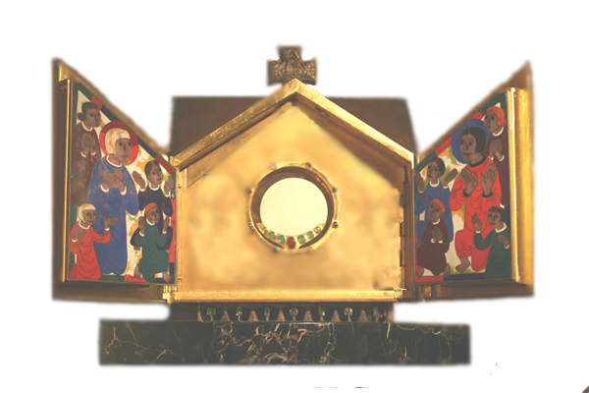
GUIDE FOR ADORERS

St. Vincent de Paul Church
Huntington Beach, Ca

Introduction
Our goal is to adore our God and Savior Jesus Christ, truly present in the Eucharist, and to provide the opportunity, through scheduled hours of Adoration, for others to come and adore our Lord as well.

CONTACTS
An Adorer Directory of other adorers who have given permission to publish their names is available to members and should be kept private.
Society Coordinator:
Steve Lovison (714) 943-1038
lovison@adorationservants.org
Division Leaders:
Volunteer Needed 9 AM to 4 PM
Frank Martinez 5 PM to 11 PM (714) 965-0099
Volunteer Needed Midnight to 6 AM

MY TIME
DAY:________________ HOUR: _________

THE Real Presence
Jesus Christ is present Body, Blood, Soul, and Divinity in the Blessed Sacrament. This is a “real presence.” It is not a symbolic presence.
THE EUCHARIST IS JESUS!
Jesus gives us His Body and His Blood for eternal life (John 6). The same God who was born of the Virgin, adored by the Magi, who died on the cross and rose from the dead also gives Himself to us in the Eucharist.
Bread and wine become the Body and Blood of Jesus Christ at the Consecration of the Mass. Their accidental qualities (flavor, color, taste, etc) remain the same while their substance as bread and wine are transformed into Jesus, Who is fully man and fully God. We call this change transubstantiation. The Consecrated Bread /Host is Jesus.
Since the Eucharist is truly Jesus, Catholics practice Eucharistic Adoration. We adore Jesus who is God.

Tabernacle & Monstrance
The Tabernacle reserves the Eucharist (Host) to bring Holy Communion to the sick/homebound and for adoration.
The Monstrance and Luna are sacred vessels that hold the Eucharist for Exposition.
Eucharistic Adoration takes place anytime you pray before the Eucharist (also called the Blessed Sacrament).
Eucharistic Exposition is when the Eucharist is visible in the Monstrance or Luna. Due to this Real Presence, we never leave the Eucharist unattended during Exposition.

Exposition Hours
These hours are when our Lord is exposed in the Monstrance or Luna. Church Law states firmly that during Exposition, Our Lord MUST NEVER BE LEFT ALONE. Adorer attendance is critical during hours of Exposition. Finding substitutes is a must. We must always be ready to prevent a vacant Church or Chapel during times of Eucharistic Exposition.

Non-Exposition Hours
These hours are when our Lord is not exposed in the Monstrance or Luna; but is reserved in the Tabernacle. There is no need for sign-ins or substitutions.

Genuflection
In the presence the Eucharist, either in the Tabernacle or exposed in the Monstrance, adorers should genuflect, if physically able, when entering and leaving the presence of our Lord

Talking/Silence
Spending time before the presence of our Lord in adoration is generally a contemplative (quiet) time where distractions are reduced to a minimum.
Vocal prayers, songs, and conversation should not occur unless previously agreed upon and advertised as such for that hour.

Parish Prayer Before the Blessed Sacrament
Adorers pray this prayer together out loud at the beginning of each hour. This prayer is found on the prayer sheets where the Adorer sign-in sheet is located. Praying together unites adorers with the Mystical Body of Christ, the entire Church.
In addition, a list of parishioners’ names is provided weekly so that you remember their intentions during your adoration.

Sign-up Sheets
Forms for adorers to schedule themselves for weekly holy hours. The forms can be found in the Blessed Sacrament Chapel and in the literature racks in the Church. You may also sign up online at http://www.adorationservants.org. Click on the “Register as an Adorer” link and fill out the form.

Scheduled Holy Hours / SIGN-IN
Scheduled adorers begin their hour by signing in on the sign-in attendance sheet and reading the messages on the page opposite the attendance sheet. They end their hour by noting on the sign-in sheet the average number of additional adorers present that hour.
The main purpose of the attendance sheets is to ensure we have complete coverage for our adoration during Exposition.
During Exposition Hours, scheduled adorers also protect the Eucharist in the Monstrance or Luna. They should not leave at the end of their hour if the regularly scheduled adorer for the next hour has not signed in yet.
If, at the end of the hour, the scheduled adorers are not present, but other adorers are present that are not scheduled there is a possibility of our Lord being left unattended during Exposition. The exiting scheduled adorer(s) should find out if anyone in attendance (that they recognize) will commit to staying for the hour. If so, then the adorer may leave, being certain that others will stay until the next scheduled adorer arrives. The adorer should note the incident on the sign-in sheet. If no one is available to stay, the adorer should notify the Parish Office immediately (if open) and call the Coordinator and Division Leaders immediately.
Another purpose of the sign-in sheets is to communicate necessary information. This is not a prayer journal. Please try and keep this page visible. A prayer journal is also available.
It is important that you sign-in on your appointed times. You should not sign-in ahead of time and should not check your name off unless you actually attend your scheduled time. If you cannot attend the times you are scheduled, follow the procedures for finding a substitute.
Substitutes should check the name of the person they are substituting for.

Finding Substitutes
In the event they cannot keep their appointment with the Lord, it is the adorers’ first responsibility to arrange for a substitute according to the procedure described below:
- Notify the Society via email of a vacancy. Do not wait for an answer.
- Get a family member, friend or neighbor to take your hour. This evangelization technique gets someone in front of our Lord for an hour who would not normally do so. Our Lord will inspire them.
- Call one of the other adorers for your hour to insure that someone will be there.
- Switch with an adorer from another day or time.
- Call your Division Leader or Coordinator.

Substitute Adorers
These individuals have expressed willingness to substitute for regular adorers.
The ordinary person to arrange for a substitute to fill-in a given hour is the Division Leader. This needs to be done only after the normal means to fill-in the hour do not succeed.

Changing your holy hour
To change your time let your Division Leader or Coordinator know, or change your time yourself on the web.
If only one or two adorers are scheduled during an hour of Exposition and you change your hour, please make a special effort to let the Division Leader and/or Coordinator know so substitutes can be found and the schedule updated.

Late Night Adoration Hours
The Chapel is left open from approximately 6:00 AM to 9:00 PM. After 9:00 PM entrance to the chapel is via combination lock. If no one is in the Chapel after 9:00 PM the last adorer must ensure the door is locked by fully closing the door. While in the Chapel during late night hours, the adorers present may or may not lock/close the chapel door for their safety. It is completely up to the discretion and comfort of late night adorers to admit persons who knock. You should not open the door for strangers.

Chapel Combination Lock
The combination code to the Chapel door will be given out on request only by the Parish Office. ID is required as a list is maintained for all who have the combination. Do not share this code with others.

AIR / HEAT ENERGY SAVINGS
The last person to leave the chapel should turn off the lights. To learn how to use the air / heat thermostat, please see either the Coordinator, Division Leader or Pastor.
If you turn it "on" you must also turn it "off" regardless of who is in the Chapel. Effort should be made to save energy.

Chapel Organization
The Blessed Sacrament Chapel should be kept clean and adorers are asked to help maintain its cleanliness and to keep the Chapel organized by placing all items back in the organizer and not just left on the table.

UNAUTHORIZED Literature
Devotional items and literature are not to be left in the Chapel for distribution without parish approval. All unapproved items will be thrown into the trash.

